50.001 Team 1C

Pick Before Go

Redefining the last minute, endless picking Pick & GO shopping experience

[(Github Link)](https://github.com/kelliesyhh/SUTD-CSD-Term4-50.001-1DProject-PickBeforeGo.git)

Members

Chong Pok Shun (1004992)

Lee Wai Shun (1005115)

Lek Jie Wei (1005007)

Mah Yi Da (1005024)

Sim Yu Hui, Kellie (1004204)

Wang Yanbao (1004865)

Zhang Tianqin (1004878)

Table of Contents

Background

Problem Statement

Proposed Solution

System Design and Implementation

System Architecture

Helper Classes

GetProductHelper

PromotionHelper

Concepts Used

Adding New Products, Editing Existing Products

Anonymous Class

Creating a New User Account

Anonymous Class

Generic Classes/Interfaces

Logging into An Existing Account

Android Lifecycle

Other Key Technical Features

User Authentication

User Database

Products Database

RecyclerView

Delegation

Unit Testing

Allocation of Manpower

Future Work

Push Notifications

Making Use of Pick & GO’s Smart Technology

Enhancing the User Experience

Conclusion

Appendix

Poster

App Screenshots

Video Link

Credentials to Test App

# Background

## Problem Statement

As shoppers and users of the Pick & GO app, we want to be aware of the availability of the stock of our favourite products at any point in time. Additionally, to save money and time, we want to be informed of upcoming promotions.

Personally, we want to know when products would be restocked, so that we can make plans for future purchases accordingly. We also want to know if a product is out of stock, so that we can make an informed choice before patronising Pick & GO. However, the current app offers none of these features. All that can be done on the app is generating a QR code to enter the shop, viewing past purchases and viewing possible rewards. As such, we see the significance in developing this solution for ourselves and our peers, especially for those facing similar issues as us.

## Proposed Solution

Tired of going to Pick & GO only to find out that the item you want to buy is out of stock? Want to stay updated on promotions of the most popular items? Introducing the Pick Before Go app, a revamped user experience where users can get the most out of their Pick & GO experience.

Opening the app brings you to our home screen, with the classic QR code for entry and a promotion carousel to view the current promotions in store. To browse through the product catalogue on your way to Pick & GO, simply use the search bar in the app to search for any product and tap on it. Not only will you be able to see its availability, you will also get to see a short description about it! You can even favourite items for quick access.

But Pick & GO wouldn’t survive without the operational staff restocking the items everyday. With special administrator privileges, staff can also use the app as an inventory tool for operational tasks such as updating the promotions and availability of items. They can also easily add a new product if needed!

With Pick Before Go, shopping at Pick & GO has never been easier and fuss-free!

# System Design and Implementation

## System Architecture

## 

## Helper Classes

### GetProductHelper

This helper class performs a call to the Firebase Realtime Database, to get the list of products stored in the database. The children of the database obtained are stored in an ArrayList of Product objects, which will be used for other parts of the application (eg: product catalogue).

### PromotionHelper

This is a simple helper class that takes in the current price of a product, and its allocated promotion value as Strings. We make the calculation of the new price of the product after its given promotion using the BigDecimal class and then return this value as a string.

*h*

## 

## Concepts Used

### Adding New Products, Editing Existing Products

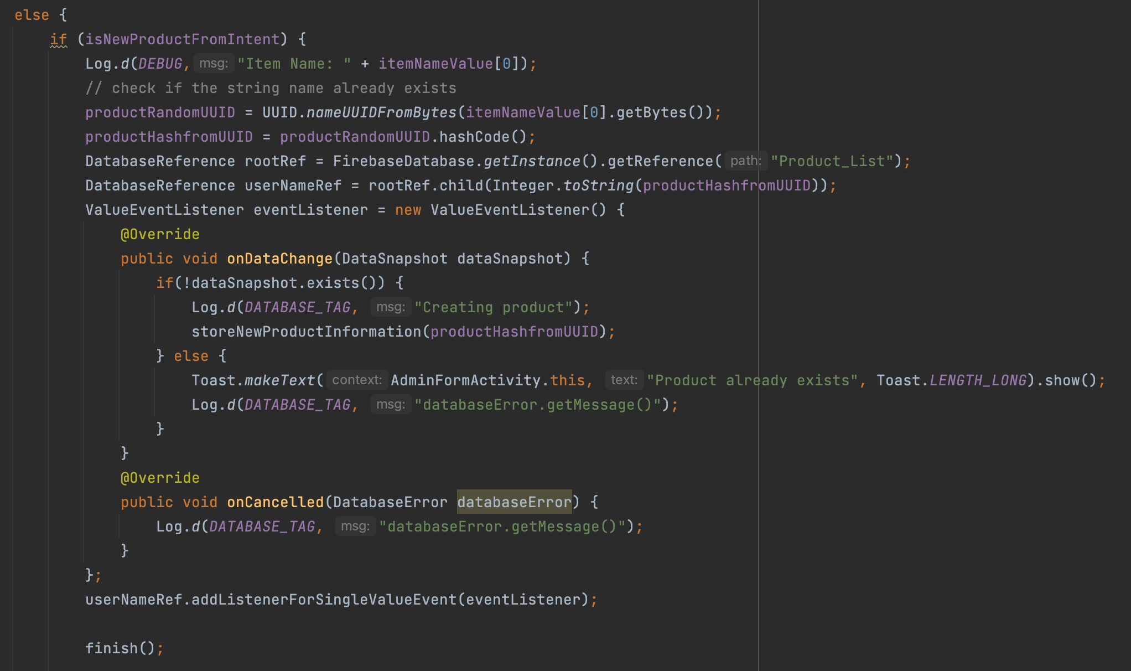

#### Anonymous Class

When uploading new products, apart from validating the EditText and ImageView, we use the onDataChange(DataSnapshot dataSnapshot) method to check if the current product is already stored in the database.

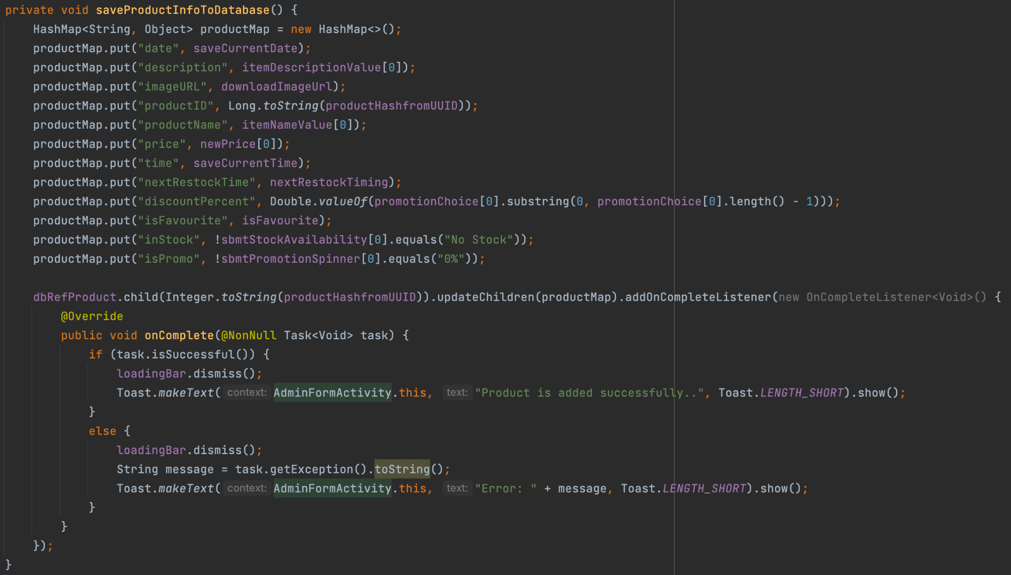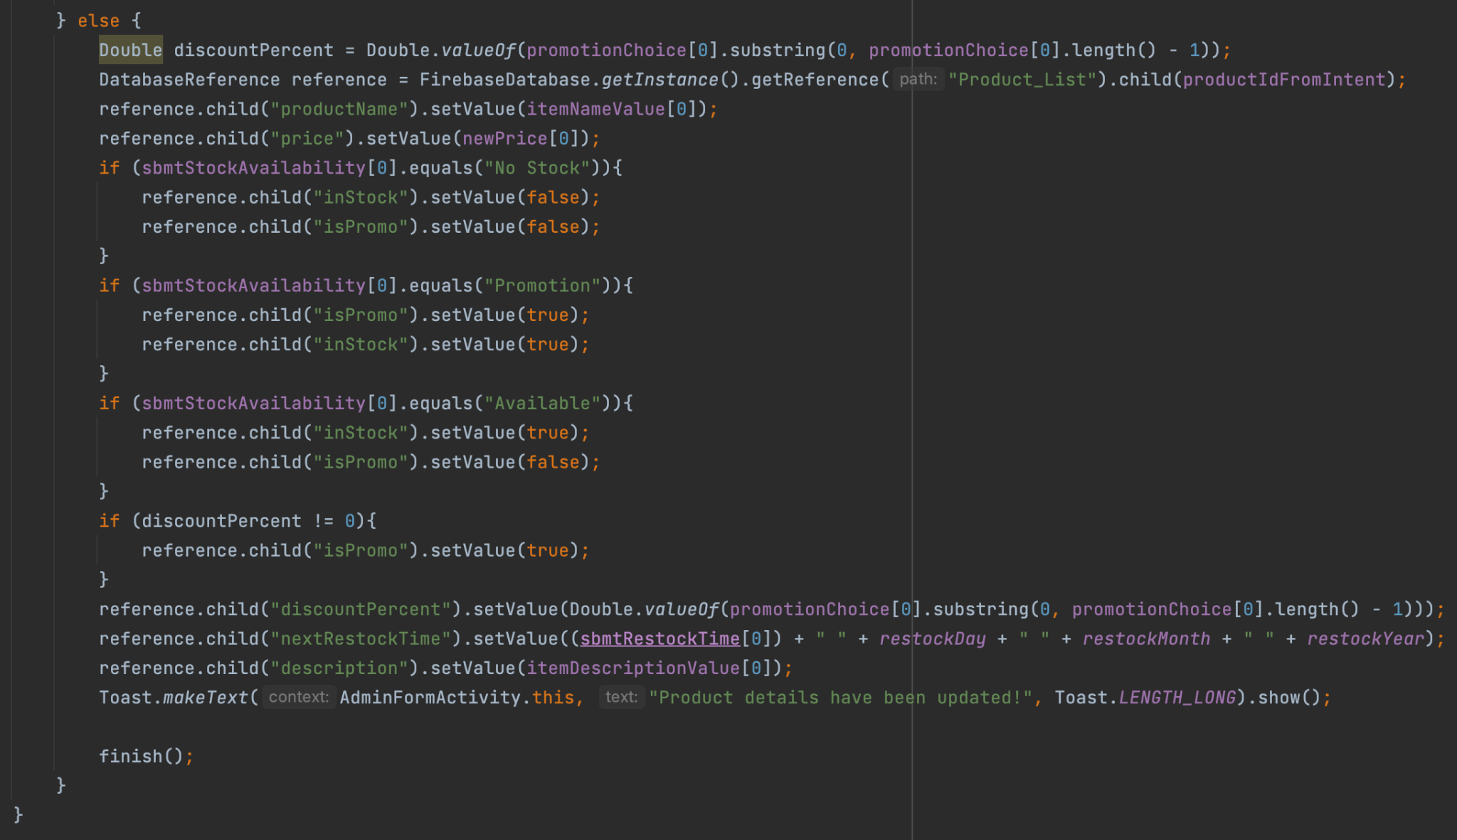

*Uploading product to database Updating product details*

storeNewProductInformation(int productHashfromUUID) and saveProductInfoToDatabase() will be called to store the information of the product into the database, otherwise the attributes of the selected product will be updated.

### Creating a New User Account

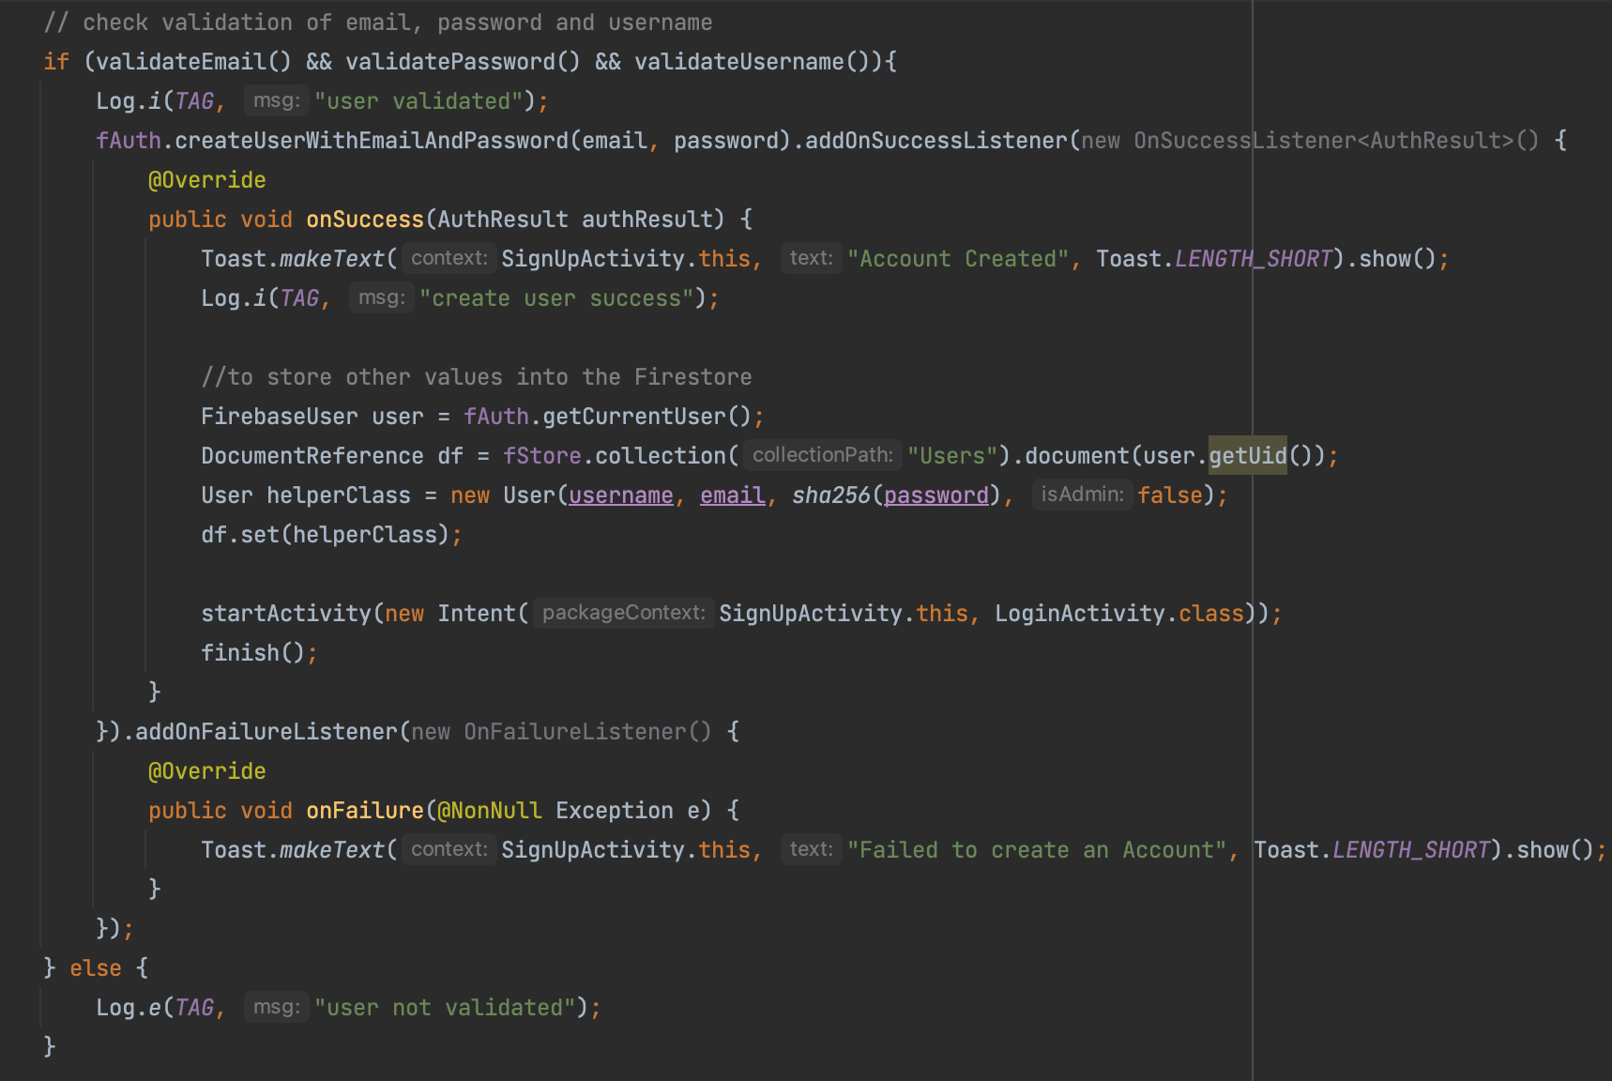

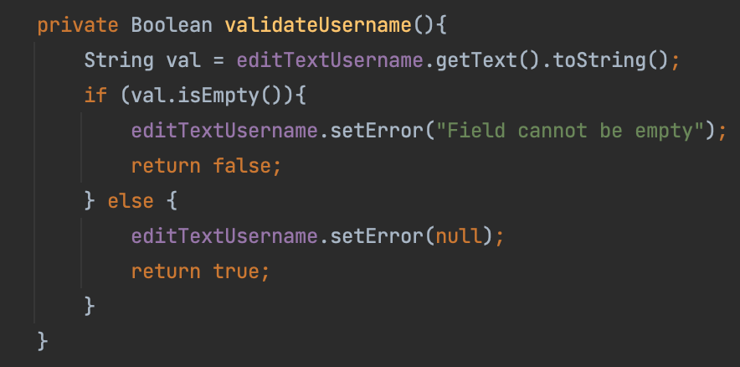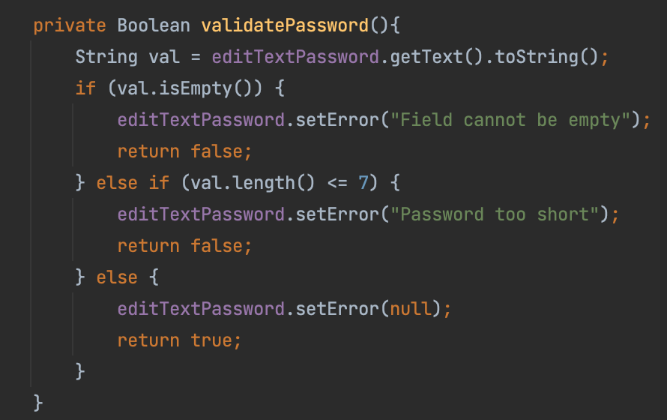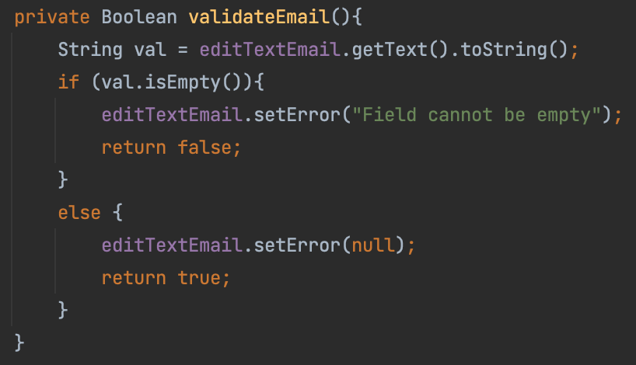

Validation methods used, apart from setting the inputType of the EditText components, include the validateUsername(), validatePassword(), and validateEmail() methods.

#### Anonymous Class

When creating a new user, the createUserWithEmailAndPassword() method of the FirebaseAuth object is called. In order to check whether the creation is a success, the addOnSuccessListener() method of a Task object is called.

An anonymous object that implements the new OnSuccessListener<AuthResult>() interface is then created, by implementing the abstract onSuccess(AuthResult authResult) method. Likewise, the addOnFailureListener() method is called to check if the creation is a failure. An anonymous object implementing the new OnFailureListener() interface is then created, by implementing the abstract onFailure(@NonNull Exception e) method.

#### Generic Classes/Interfaces

The new OnSuccessListener<AuthResult>() generic interface was used as an input for the addOnSuccessListener() method.

### Logging into An Existing Account

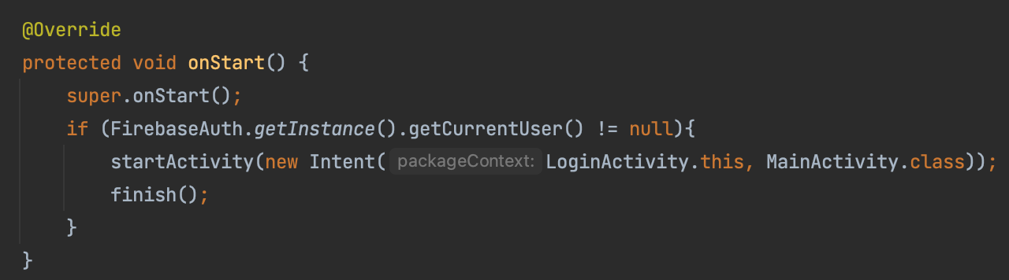

#### Android Lifecycle

Persistent login is enabled for users to enhance the user experience. To prevent the user from having to login each time they re-launch the app, the onStart() method is overridden to check if the current user has already been authenticated. If yes, the user will skip the *LoginActivity* and go to *MainActivity* immediately.

## Other Key Technical Features

### User Authentication

### 

Firebase Authentication was used alongside the Cloud Firestore database for user authentication and account creation. Upon signing up for an account, users will be registered with Firebase Authentication, which automatically assigns a unique user UID for them. This UID is used as the document’s name in the Cloud Firestore database.

### User Database

Given each User UID, we also created an object in Firebase’s Cloud Firestore to store the user information such as isAdmin and password. This creates a more scalable solution in the event that we wish to add more features by adding new attributes to the user class.

| **Data Type** | **Attributes** |
| --- | --- |
| String | username, email, password |
| Boolean | isAdmin |

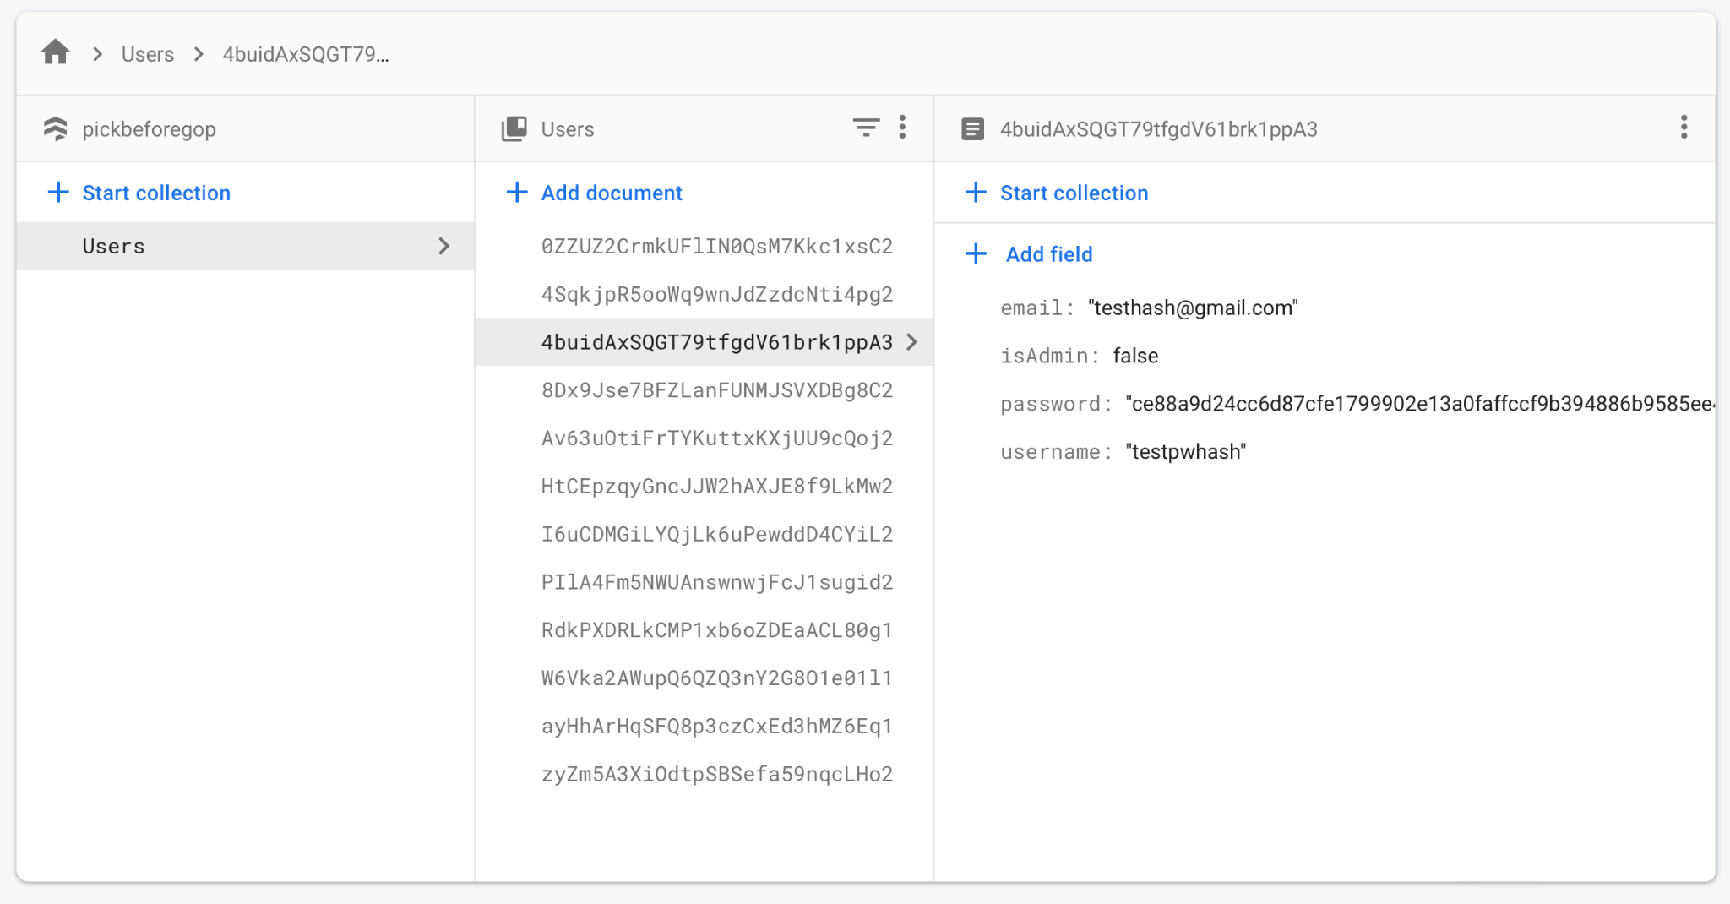

For security reasons, the SHA-256 hash function was implemented to store passwords. The above image shows an example of a hashed password, which was also used for unit testing.

### Products Database

The data of the products is stored in Firebase’s Realtime Database, for the purpose of easily editing and retrieving data. With Realtime Database storing data as one large JSON tree, we observed that it would be ideal for our use case, since the data changes frequently and is rather simple. An example of our database structure is as such:

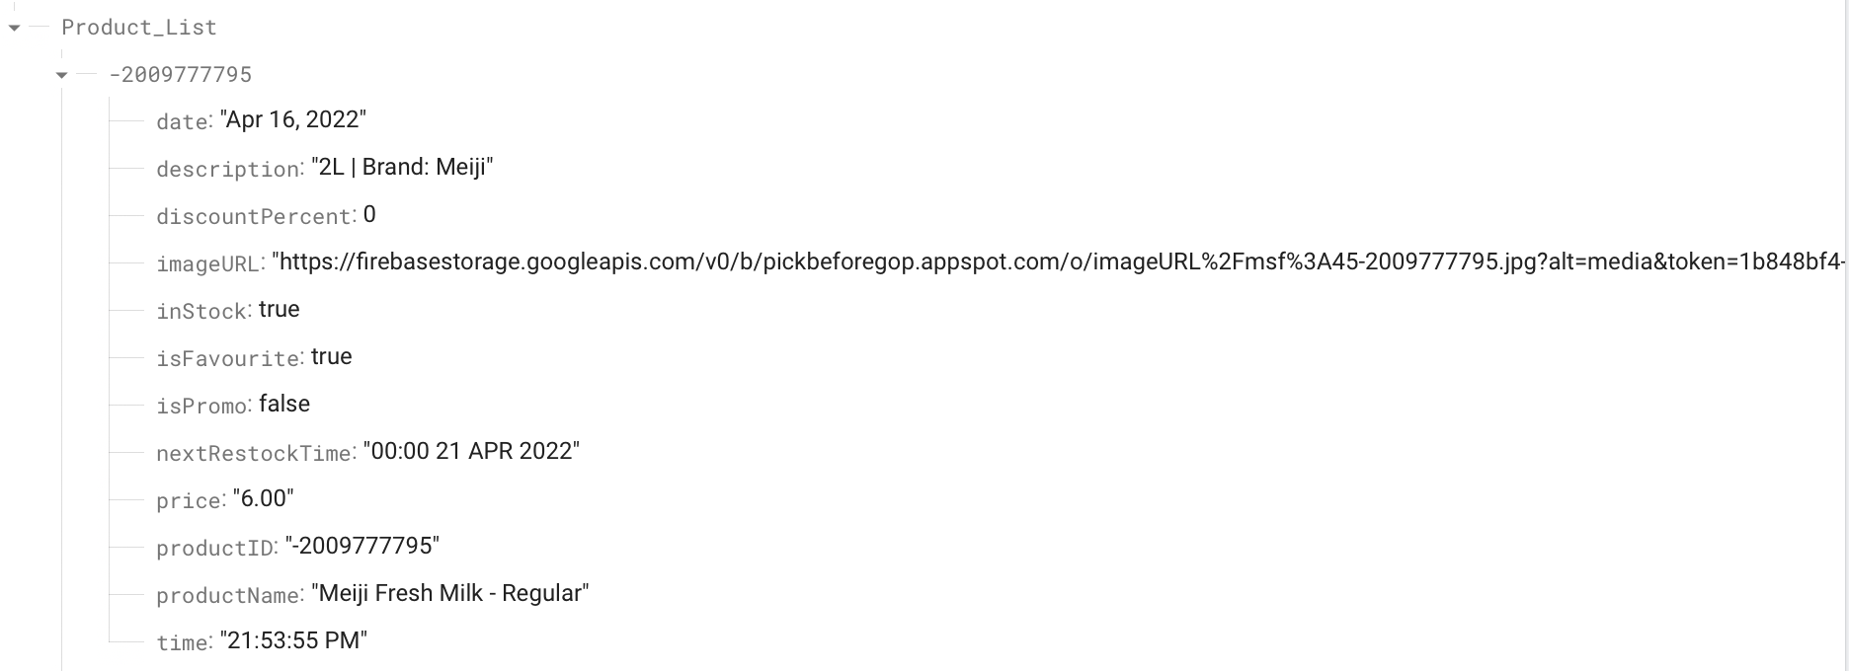

The name of each subtree is the productID attribute of the product, which was generated through hashing of the productName attribute value, to avoid redundancy and duplication of the products. Other attributes (stored as children in the database) include:

| **Data Type** | **Attributes** |
| --- | --- |
| String | date, description, imageURL, nextRestockTime, price, productID, productName, time |
| Number | discountPercent |
| Boolean | inStock, isPromo |

Admins will be able to change these attributes using different functions inside the app.

### RecyclerView

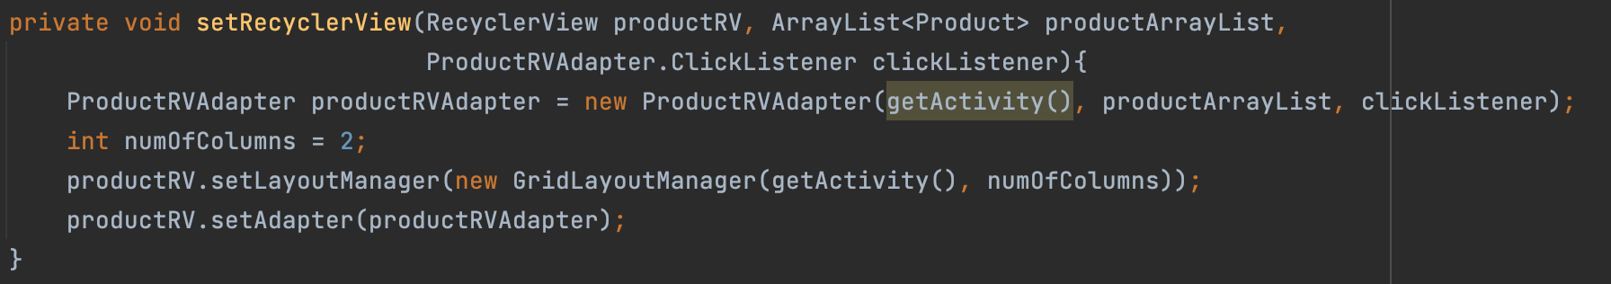

RecyclerView is implemented in both AllFragment and FavouriteFragment to display the relevant product cards on each fragment.

#### Delegation

The productRV object delegates the role of retrieving data to the productRVAdapter object and the role of managing the layout to the GridLayoutManager(getActivity(), numOfColumns) object

We allowed users to be able to click on each product card by adding a setOnClickListener() in onCreateViewHolder() method. Furthermore, data is binded to the widgets of each data item through the onBindViewHolder() method.

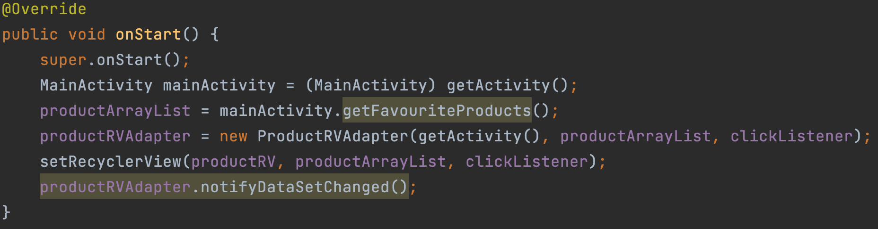

In the AllFragment and FavouriteFragment files, upon launching the Fragment, the onStart() method is overridden to update the RecyclerView with the latest products, to prevent the user from having to switch fragments each time they want to reload a particular fragment. This is done by having notifyDataSetChanged() invoked in the onStart() method.

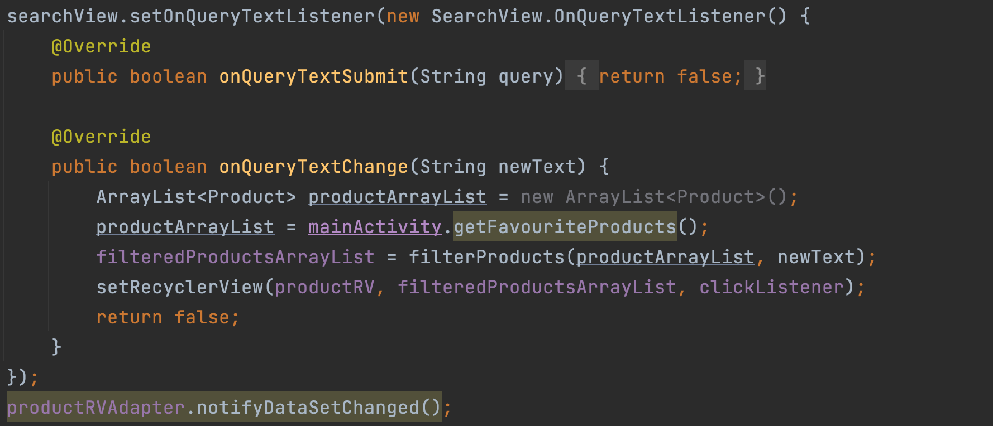

By implementing the setOnQueryTextListener() method in the SearchView object in both fragments, users are able to search their products. The ArrayList containing a list of Product objects will be updated according to what the user types, and in turn, updates the RecyclerView being shown in both fragments.

## Unit Testing

## 

To test our PromotionHelper class, we used Unit Testing, as demonstrated in the promotion_isCorrect() method above.

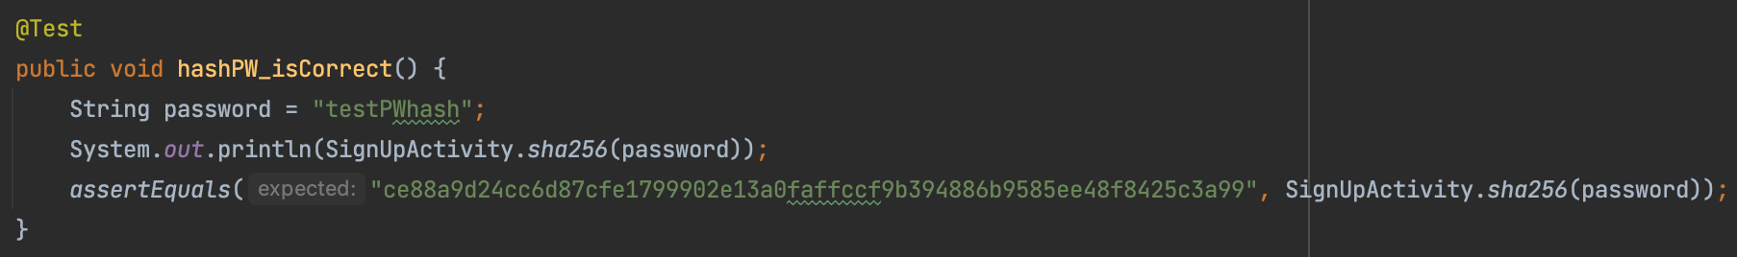

To test the sha256(String base) method used to hash passwords, we used Unit Testing and checked it against the value stored in Cloud Firestore in the hashPW_isCorrect() method above.

# Allocation of Manpower

| **Name** | **Student ID** | **Contribution** |
| --- | --- | --- |
| Chong Pok Shun | 1004992 | Admin view and form validation + Video (Director) |
| Lee Wai Shun | 1005115 | Firestore authentication and database of user information |
| Lek Jie Wei | 1005007 | Product forms and validation + Poster Design (Artist) |
| Mah Yi Da | 1005024 | Product Catalogue (All Products and Favourite Products), report |
| Sim Yu Hui, Kellie | 1004204 | Product Screen Activity page, individual product cards, refactoring code, report |
| Wang Yanbao | 1004865 | Promotion carousel, home fragment and bottom navigation bar |
| Zhang Tianqin | 1004878 | Admin Form Activity page (Add & Edit product), realtime database of products |

# Future Work

## Push Notifications

With this feature, users can choose if they would like to be notified of when items are restocked. Users would simply have to indicate that they would like to be notified (similar to a subscription to a YouTube channel), and upon reaching the date stored in the nextRestockTime attribute, a push notification will be triggered.

## Making Use of Pick & GO’s Smart Technology

In Pick & GO’s current physical store, users will be able to leave the store without scanning any items purchased as the cameras located around the store work hand-in-hand with existing AI and algorithms to detect items that have been removed from the shelf by a certain user. Making use of this technology, we can implement a live count of the stock present at Pick & GO (eg: left 2 in stock, rather than just being marked as “Available”). This feature can be extended to admin accounts, where staff can be notified once a certain item’s stock goes below a certain number and requires restocking.

## Enhancing the User Experience

Pick & GO may be a small mart, but it is a crucial part of many SUTD students’ journeys.

With the many different products that Pick & GO offers during different seasons, a rating/comment system can be implemented on each product’s page. This allows users to easily decide if a current promotion is worth running for! For admins, this can be a way to gauge the demand of a certain product.

A wishlist feature can also be implemented in conjunction with the above system. Currently, students who have enquiries about Pick & GO’s products post their enquiries in the SUTD Family Telegram chat or on their social media pages.

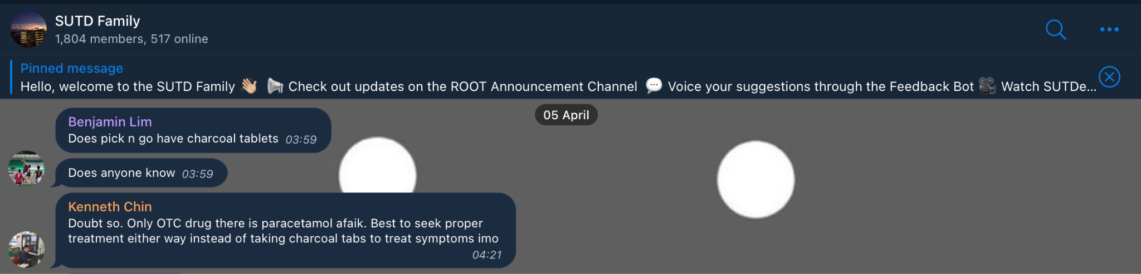

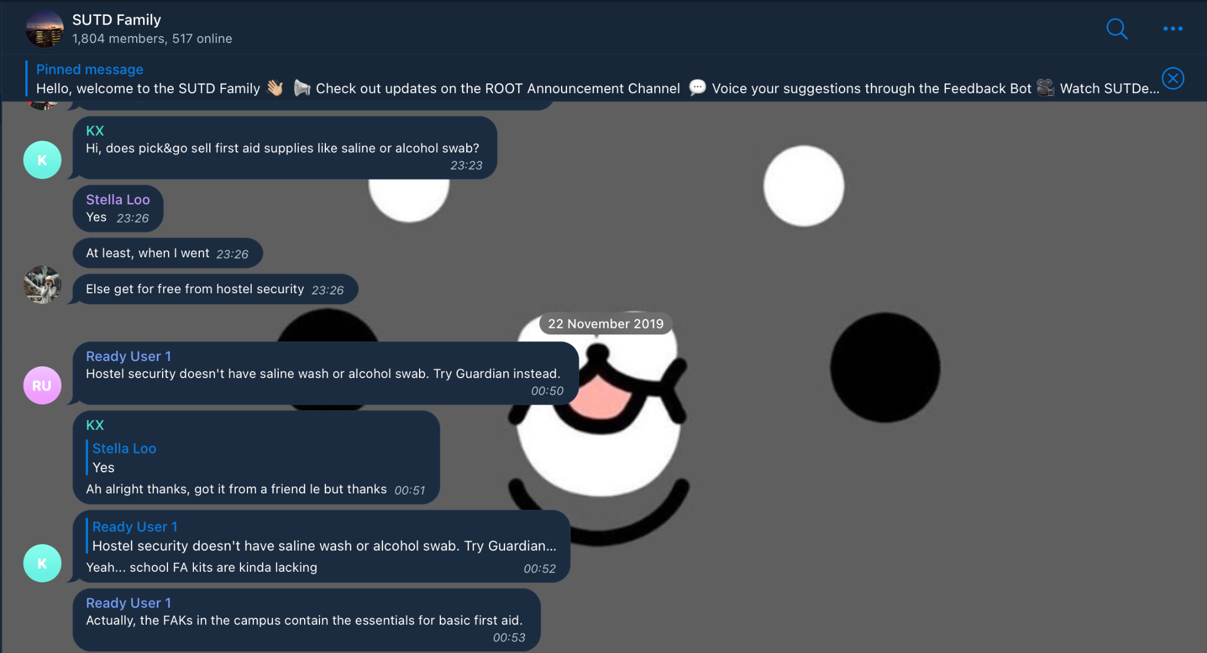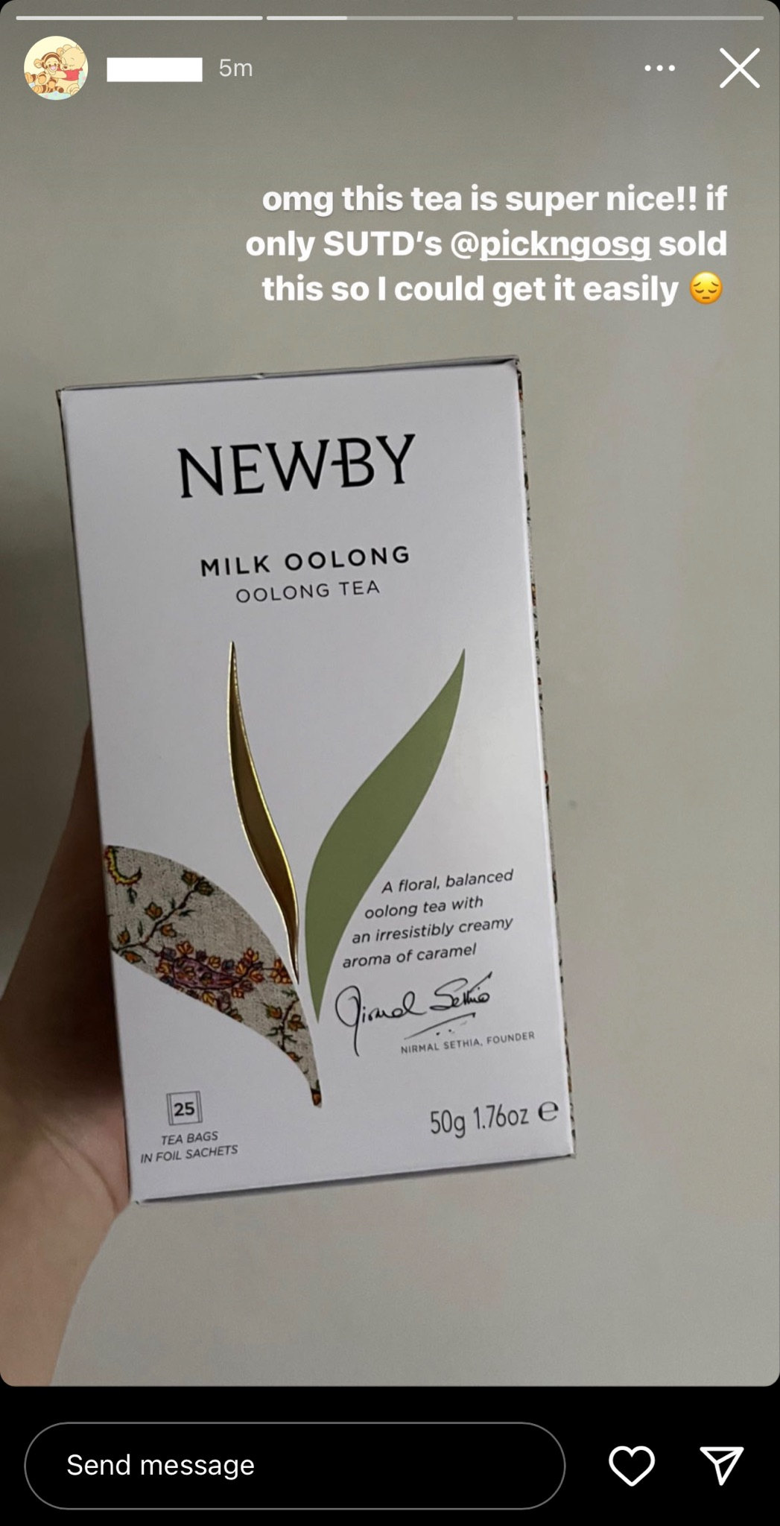

Anonymously contacting the personnel of the store about enquiries or feedback would be greatly helpful for most users, allowing common questions like this to be easily answered.

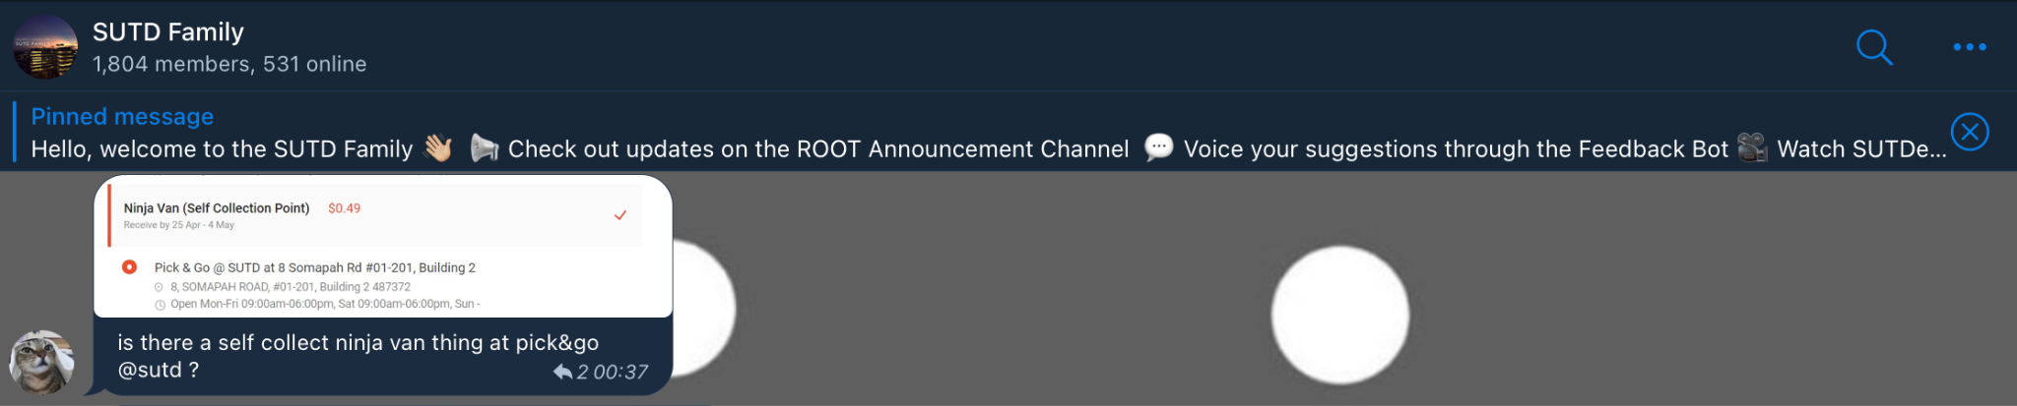

# Conclusion

By implementing various concepts taught in lessons, we were able to develop a simple yet functional Android application. We were also able to produce the features shown during the first checkoff. However, as with any project, there is always room for improvement in the final implementation of the application, in order to enhance the user experience.

# Appendix

## Poster

## 

*Fig 1. Poster for our Android app*

## App Screenshots

## 

*Fig. 2 Login and Signup page upon opening app*

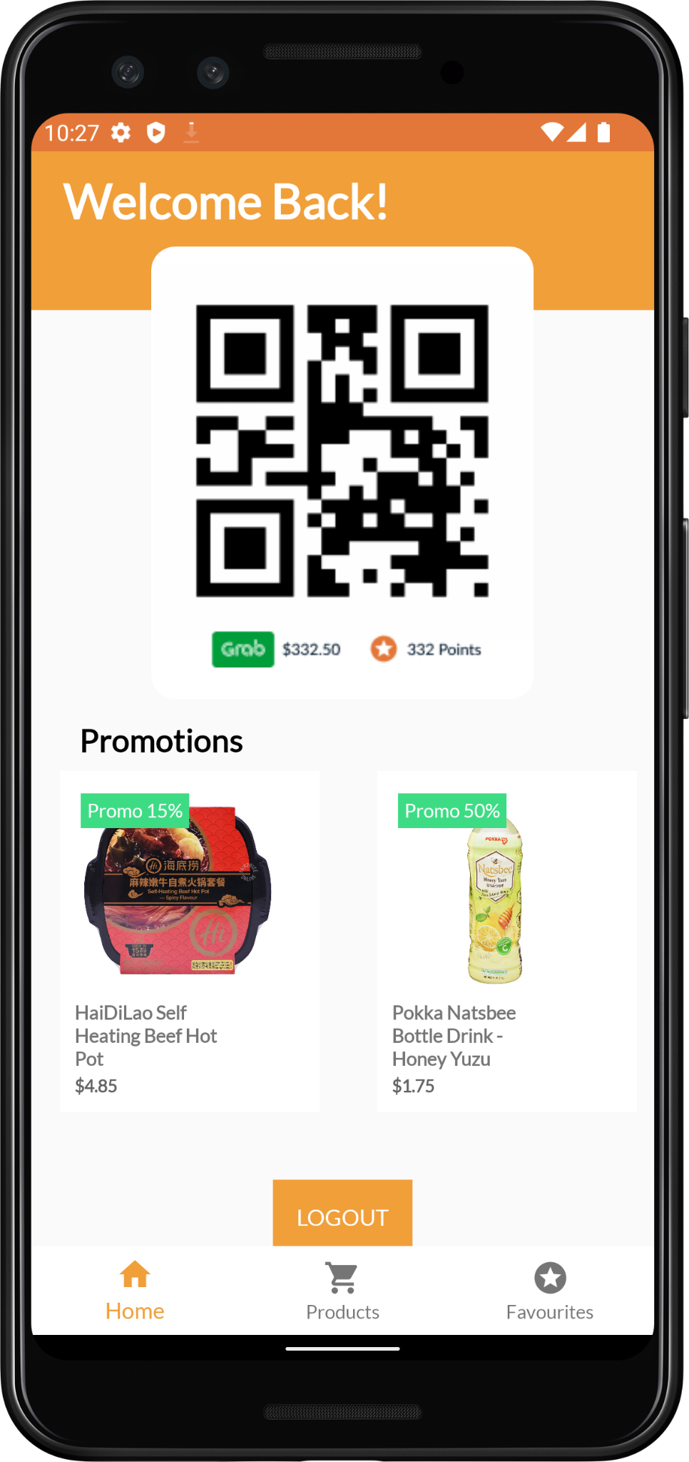

*Fig. 3 Home page with promotion carousel and logout button*

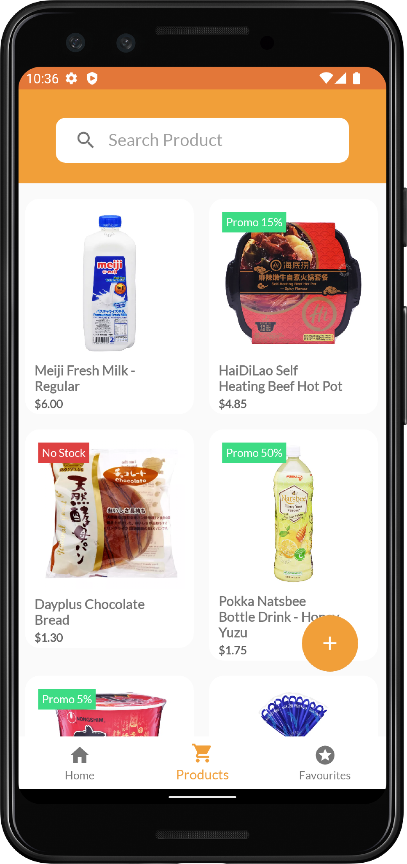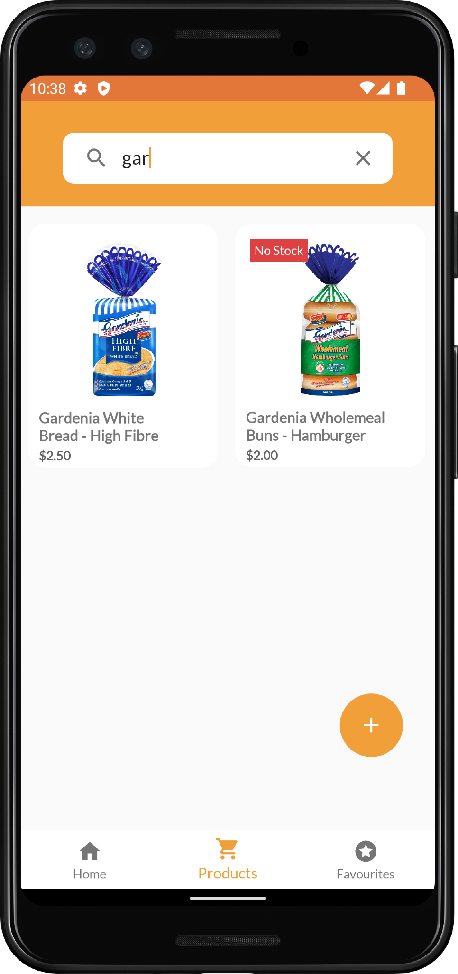

*Fig. 4 Product catalogue; search bar function*

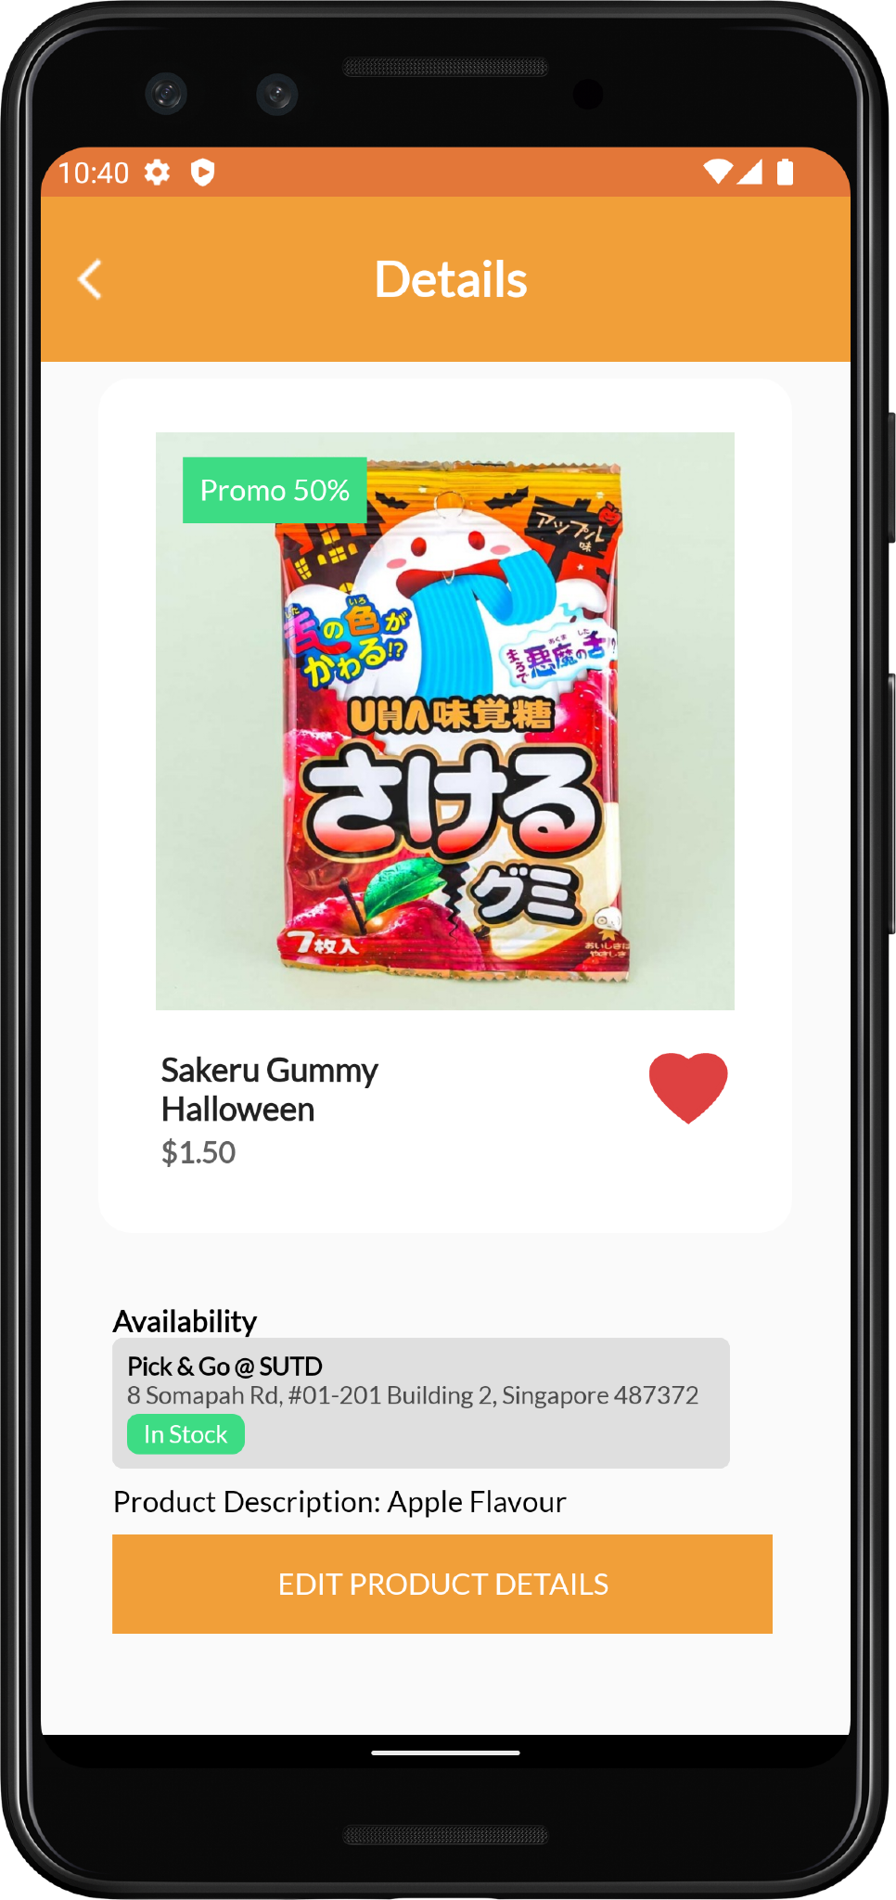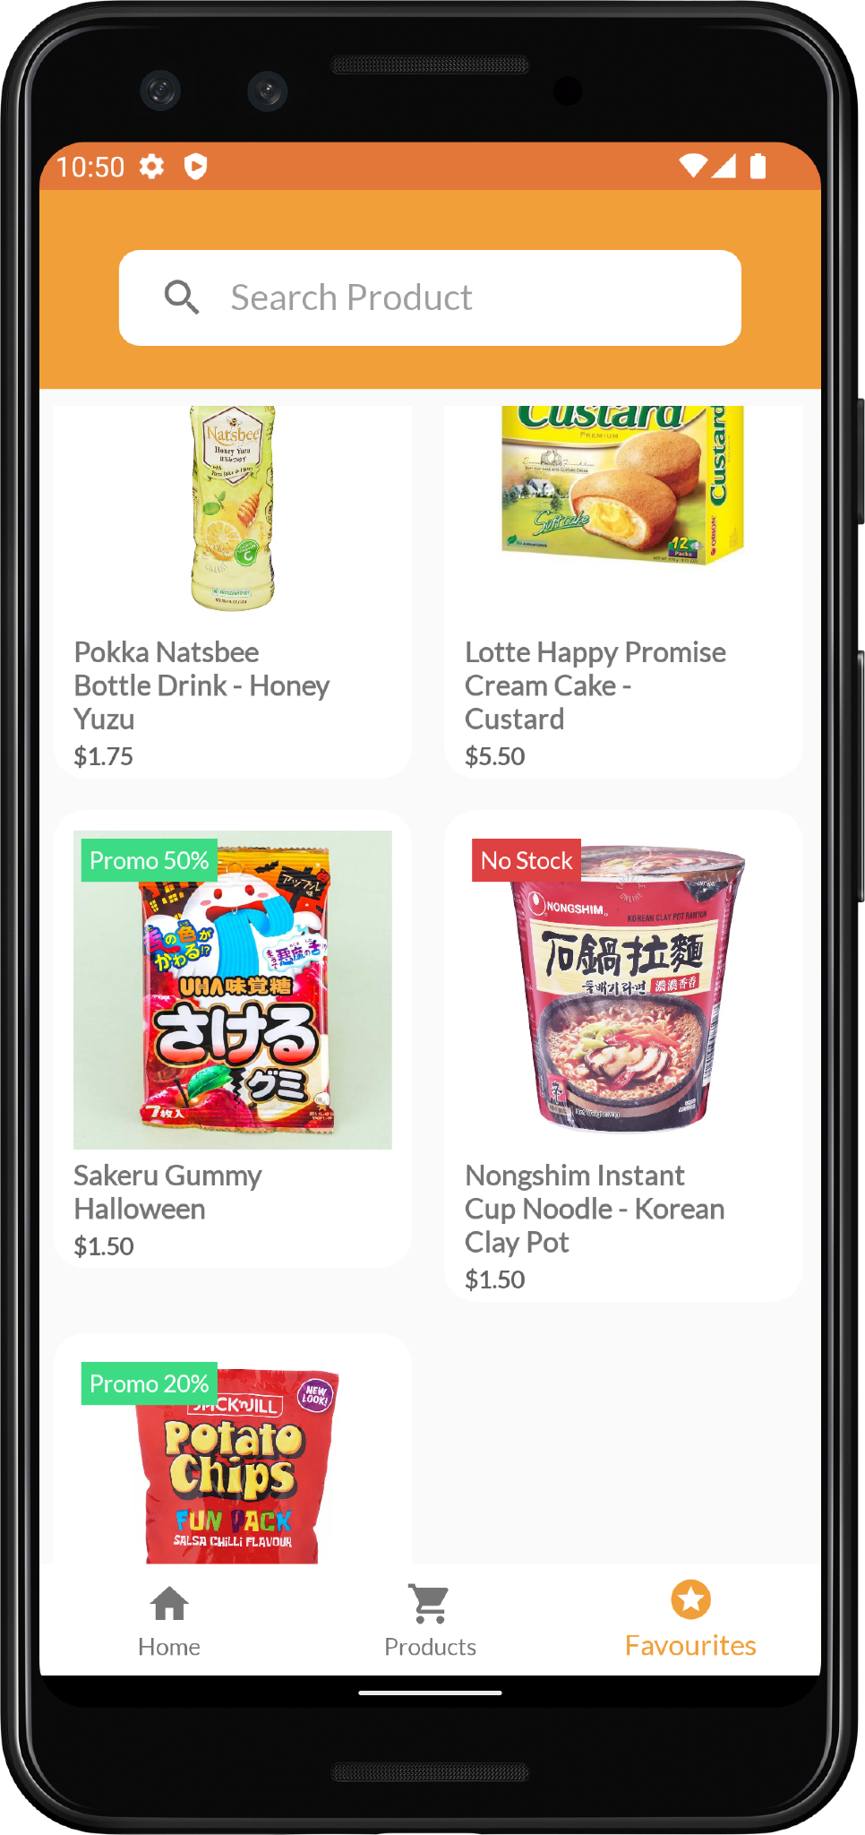

*Fig. 5 Favourited product; favourites page*

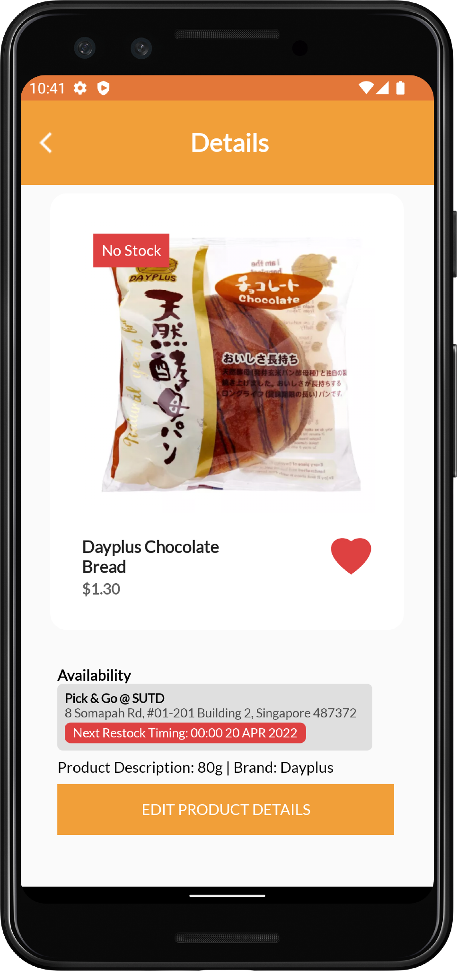

*Fig 6. Product screen activity when item is out of stock*

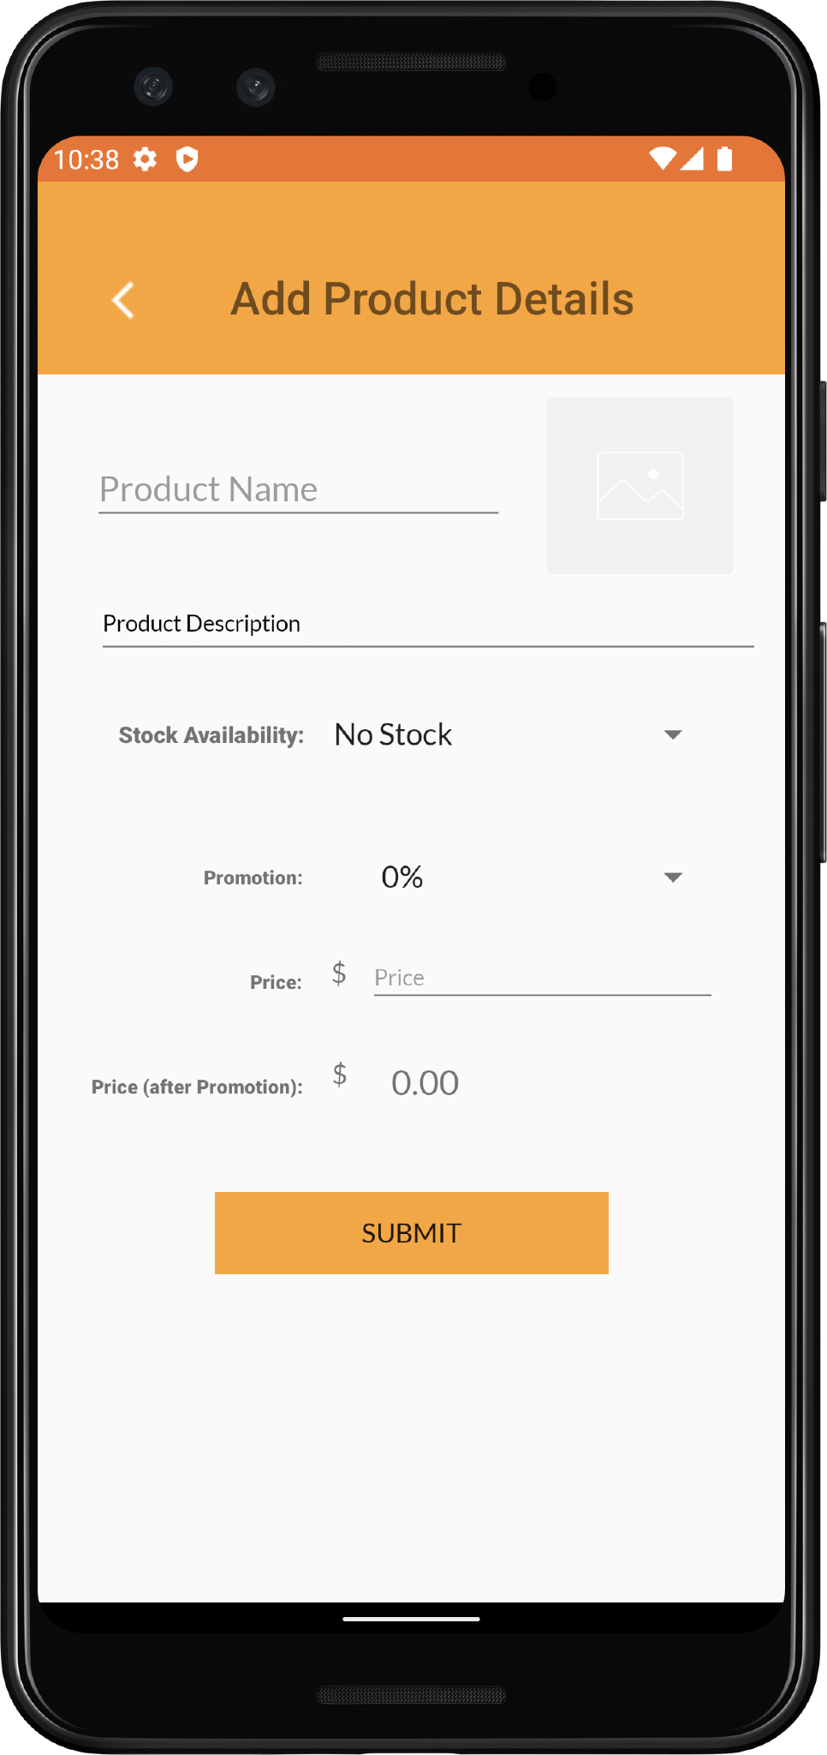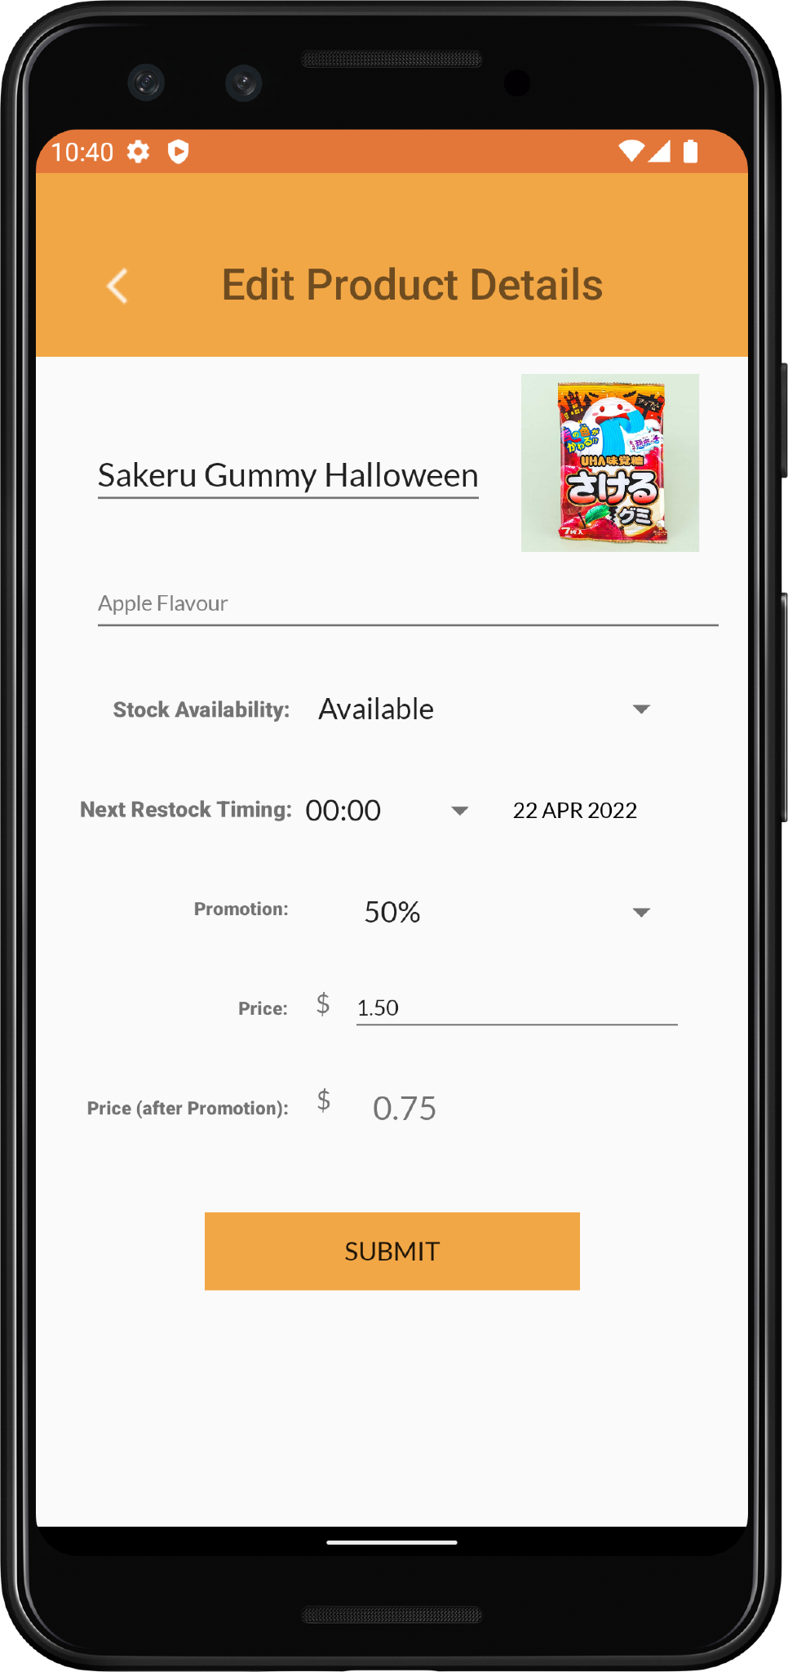

*Fig. 7 Adding new product and editing existing product forms*

## Video Link

<https://drive.google.com/file/d/1DPZkrgN_oO9rmsWWD66dUzKD0gs80uSw/view?usp=sharing>

## 

## Credentials to Test App

These are some sample credentials for users to experience the application in both admin or regular user mode.

|  | **Admin** | **Regular User** |
| --- | --- | --- |
| Email | master_adminpng@gmail.com | master_userpng@gmail.com |
| Username | master_admin | master_user |
| Password | IAmAnAdmin | IAmAUser |